**How to Reset MySQL Root Password in Windows**

**Step 1: Stop MySQL server**

1. Press **Win**+**R** (hold the Windows/Super key, and press **r**).

2. In the Run box, type *services.msc* and press **Enter**.

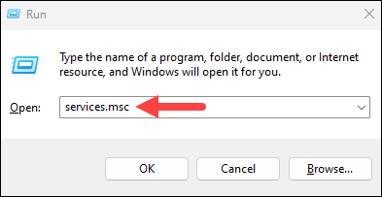

3. Scroll down the list of services to find the MySQL service. Right-click the entry and select **Stop**.

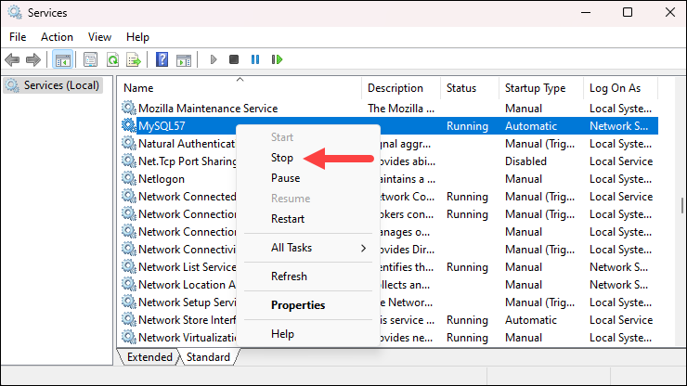

**Step 2: Create Password File**

The password file is a *.txt* document containing the [new password](https://phoenixnap.com/kb/password-generator) you want to use. Follow the steps below:

1. Press the **Windows** key and search for *Notepad*. Press **Enter** to open the app.

2. Add the following line to the text file:

ALTER USER 'root'@'localhost' IDENTIFIED BY 'NewPassword';

* Make sure to keep the quote marks and semicolon. Replace **NewPassword** with the password of your choice.
* The **localhost** string makes the password change on your local system. If you’re changing the password on a system over the network, substitute **localhost** with the appropriate hostname.

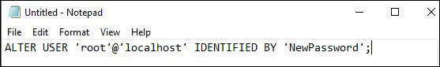

3. Save the file to the root of your hard drive (C: ). The filename should be *mysql-init.txt*.

**Step 3: Open Command Prompt**

1. Press the Windows key and type *cmd*.

2. From the search results, select the **Run as administrator** option to open Command Prompt as administrator.

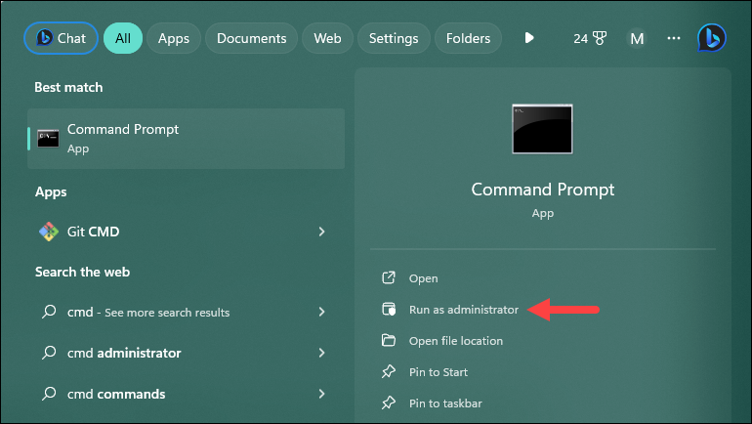

**Step 4: Add New Parameters and Restart Server**

1. Navigate to the MySQL directory using the command prompt:

cd "C:\Program Files\MySQL\MySQL Server 5.7\bin"

If you have a different MySQL version, make sure to use that version in the command.

2. Depending on how you installed MySQL, there are two ways to restart the server with the new parameters:

* **If you installed MySQL using the ZIP archive**

Run the following command

mysqld --init-file=C:\\mysql-init.txt

Note that there are two slashes after the C: prompt.

* **If you installed MySQL using the MySQL Installation Wizard**

You must specify a **--defaults-file** option in the command, followed by the path to the configuration file. Find the file path by right-clicking the MySQL service in the services list and selecting **Properties**:

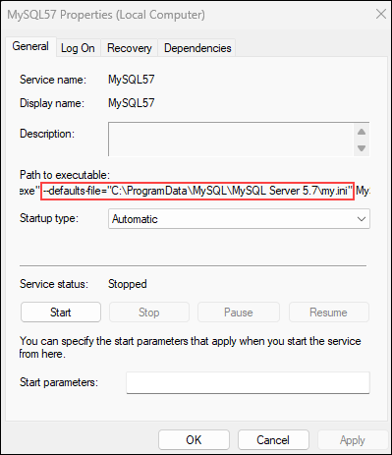

The file path is listed in the *Path to executable* section. Copy the file path and use it in the command below, but make sure to use double slashes (**\\**) instead of single (**\**) in the path:

mysqld --defaults-file="C:\\ProgramData\\MySQL\\MySQL Server 5.7\\my.ini" --init-file=C:\\mysql-init.txt

3. Restart the MySQL service from the Services list. Right-click the **MySQL**service and select **Start**.

**Step 5: Clean up**

Now, log into your MySQL server as **root**using the new password. Once MySQL launches and you've confirmed the password change, delete the *C:\mysql-init.txt* file.